**CS7050 Artificial Intelligence**

**Assignment: Heuristic Search problem**

**Problem definition:**

Given the maze on Fig. 1 (5 x 6 nodes) find the shortest path between the starting node (0.0) and the end node (4,5). The permitted moves are four: **Left**, **Right**, **Up** and **Down,** the red nodes contain obstacles and no movements in them are possible through them. The boundaries are walls which are blocking the movements.

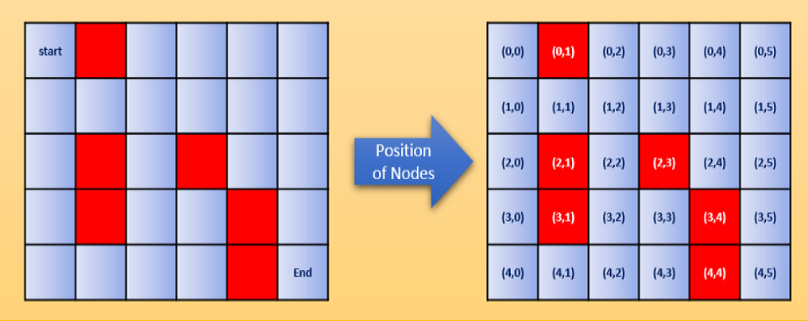

**Fig. 1 The Maze Problem**

**Solution:**

To develop a Python program which finds the shortest path from the start node to the end node of the maze and to write a report. The code of the program and the report must be submitted to WebLearn by the deadline and will be demonstrated during the last workshop before the exams (Week 12).

**Group tasks: Max 50 marks**

1. Chose a suitable representation of the maze nodes using the available Python data 5 marks

structures. You must define all attributes representing the information you need

1. Define the success criteria for reaching the end node. 5 marks
2. Define the path function which accumulates the past nodes into a path 5 marks
3. Define suitable heuristic function to estimate the cost on each path 10 marks
4. Define the algorithm for heuristic search considering the success criteria, the 10 marks

permitted moves in each node and the cost

1. Build the representation of the maze by creating start node, end node and red nodes 5 marks

according to the diagram on Fig. 1.

1. Run the program and output the optimal path found by the algorithm 10 marks

**Additional tasks for individual work max 30 marks**

1. Implement additional algorithm for solving the problem using different technique

(Constraint Propagation, Rule-Based, Dejkstra, etc.)

1. Implement the A* with different heuristic function
2. Design a board to represent the maze in 2D plain (in text or graphics mode)
3. Trace the attempted nodes during the search process
4. Visualize the search paths during the execution

**Report**  **max 20 marks**

The group report must explain the decisions and the code. Its structure must follow the tasks as specified above.

**Notes:**

1. The basic tasks are scored max 50% which means that in order to pass is needed to have a group report (50% is a pass mark)
2. The additional tasks are scored max 30% which means that without attempting any of them the mark cannot be a distinction (70% is required for distinction)
3. The report is only 20% which means that without code and any additional individual work the overall score will be a fail
4. The group viva is not marked but without it the code will be discarded and only the report will be marked, which means fail (max 20%)
5. The additional individual work does not require additional reporting but without individual demonstration the code will be discarded and only the group part will be marked (max. 70 marks so no distinction)